**//Program to swap two numbers without using ternary variable**

#include<stdio.h>

int main()

{

int x,y;

printf("enter x value:");

scanf("%d",&x);

printf("enter y value:");

scanf("%d",&y);

x=x*y;

y=x/y;

x=x/y;

printf("After swap x=%d and y=%d",x,y);

return 0;

}

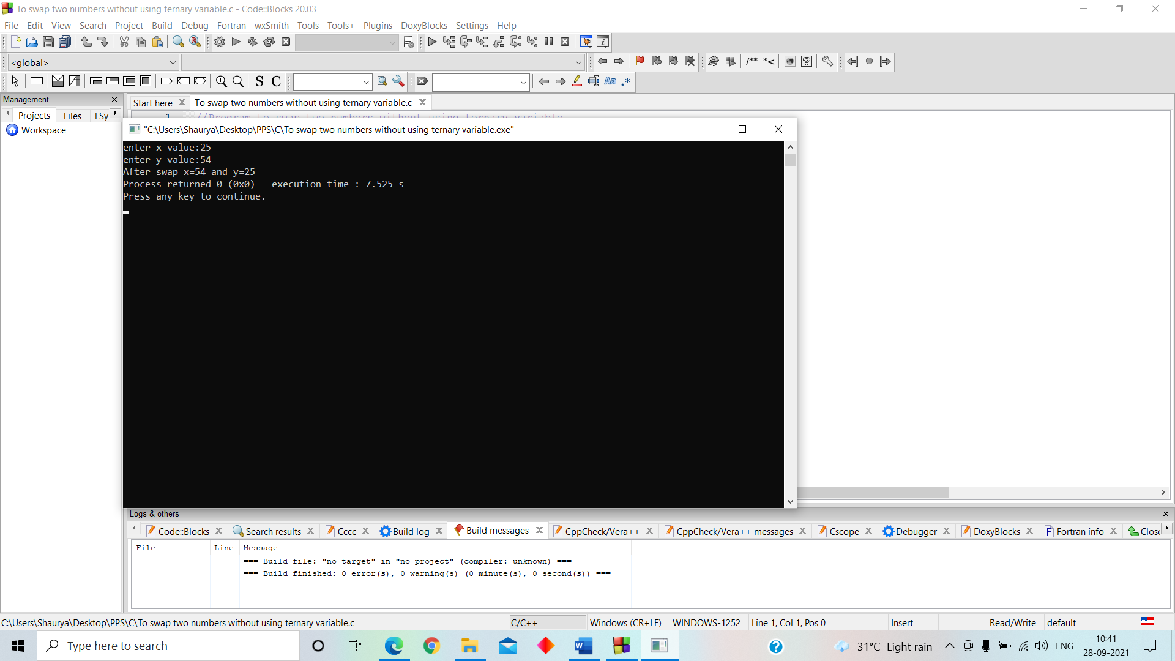OUTPUT-

**//Greatest of three numbers using ternary operator**

#include <stdio.h>

int main()

{

int a, b, c;

printf("Enter three numbers: ");

scanf("%d %d %d", &a, &b, &c);

int result=(a>b)?(a>c?a:c):(b>c?b:c);

printf("Largest of three numbers is %d ", result);

return 0;

}

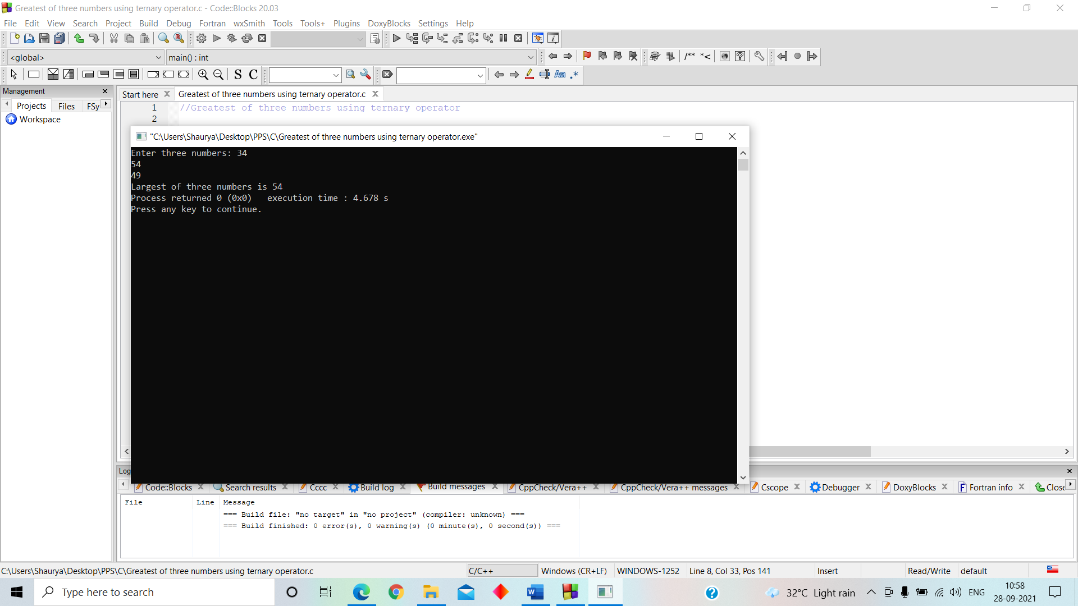OUTPUT-

**//Read a decimal number and display octal number.**

#include <stdio.h>

int main()

{

int number;

printf("Please Enter the Number You want to Convert: ");

scanf("%d",&number);

printf("Octal Number of a Given Number= %o", number);

return 0;

}

OUTPUT-

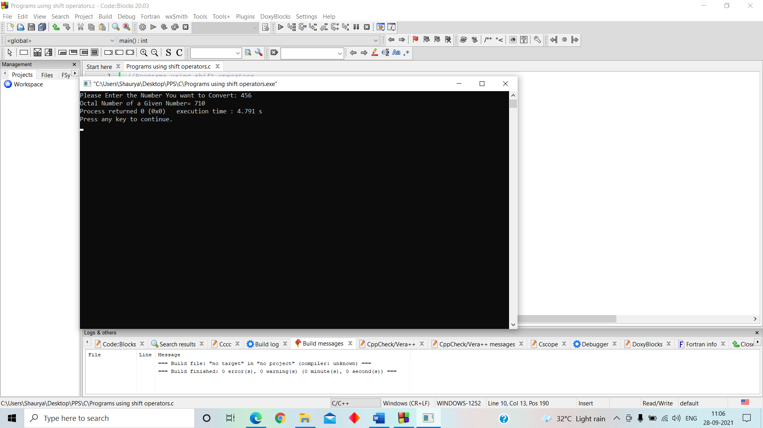

**//Read a decimal number and display hexadecimal number.**

#include <stdio.h>

int main()

{

char c;

printf("Enter a character: ");

scanf("%c", &c);

printf("ASCII value of %c = %d", c, c);

return 0;

}

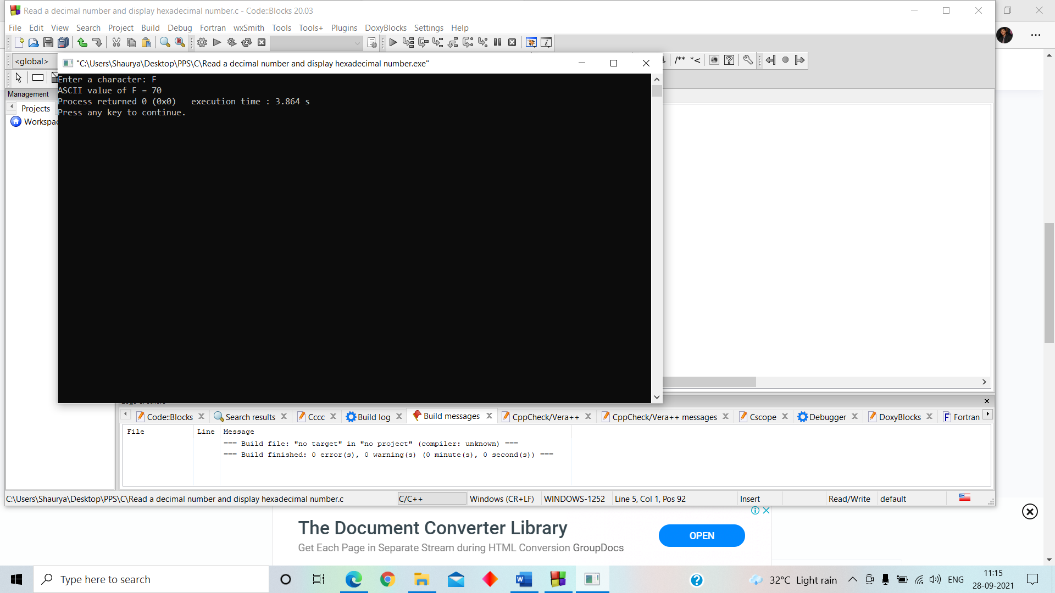OUTPUT-

**//Read a name and display it with greeting message.**

#include <stdio.h>

int main()

{

char name[25];

printf("enter your name: ");

scanf("%s",&name);

printf("%s",name);

}

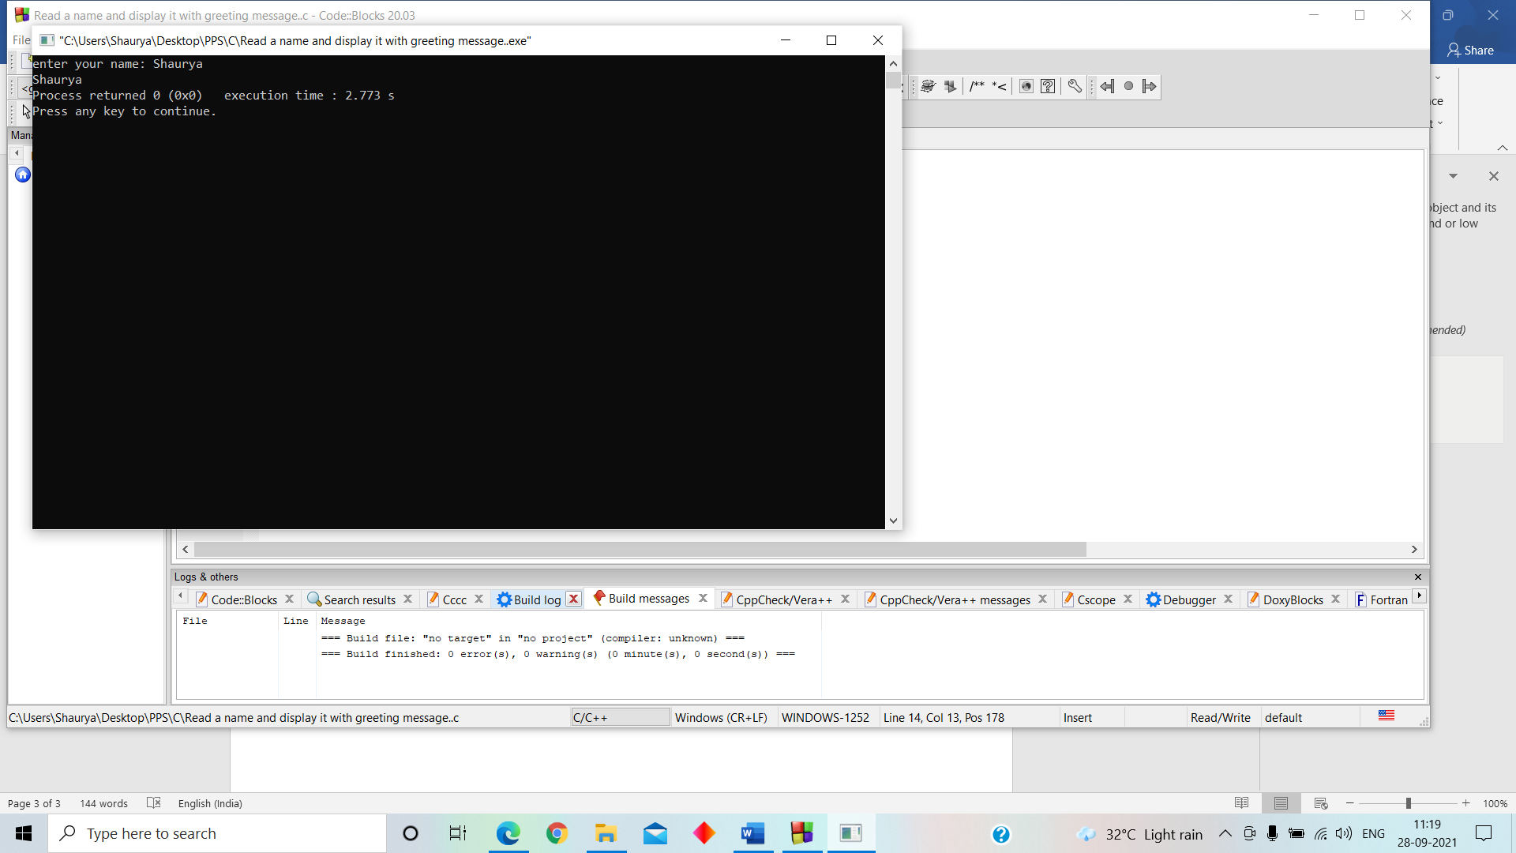OUTPUT-

**//Programs using left shift operator**

#include<stdio.h>

int main()

{

unsigned char a = 5, b = 9;

printf("a<<1 = %d\n", a<<1);

printf("b<<1 = %d\n", b<<1);

return 0;

}

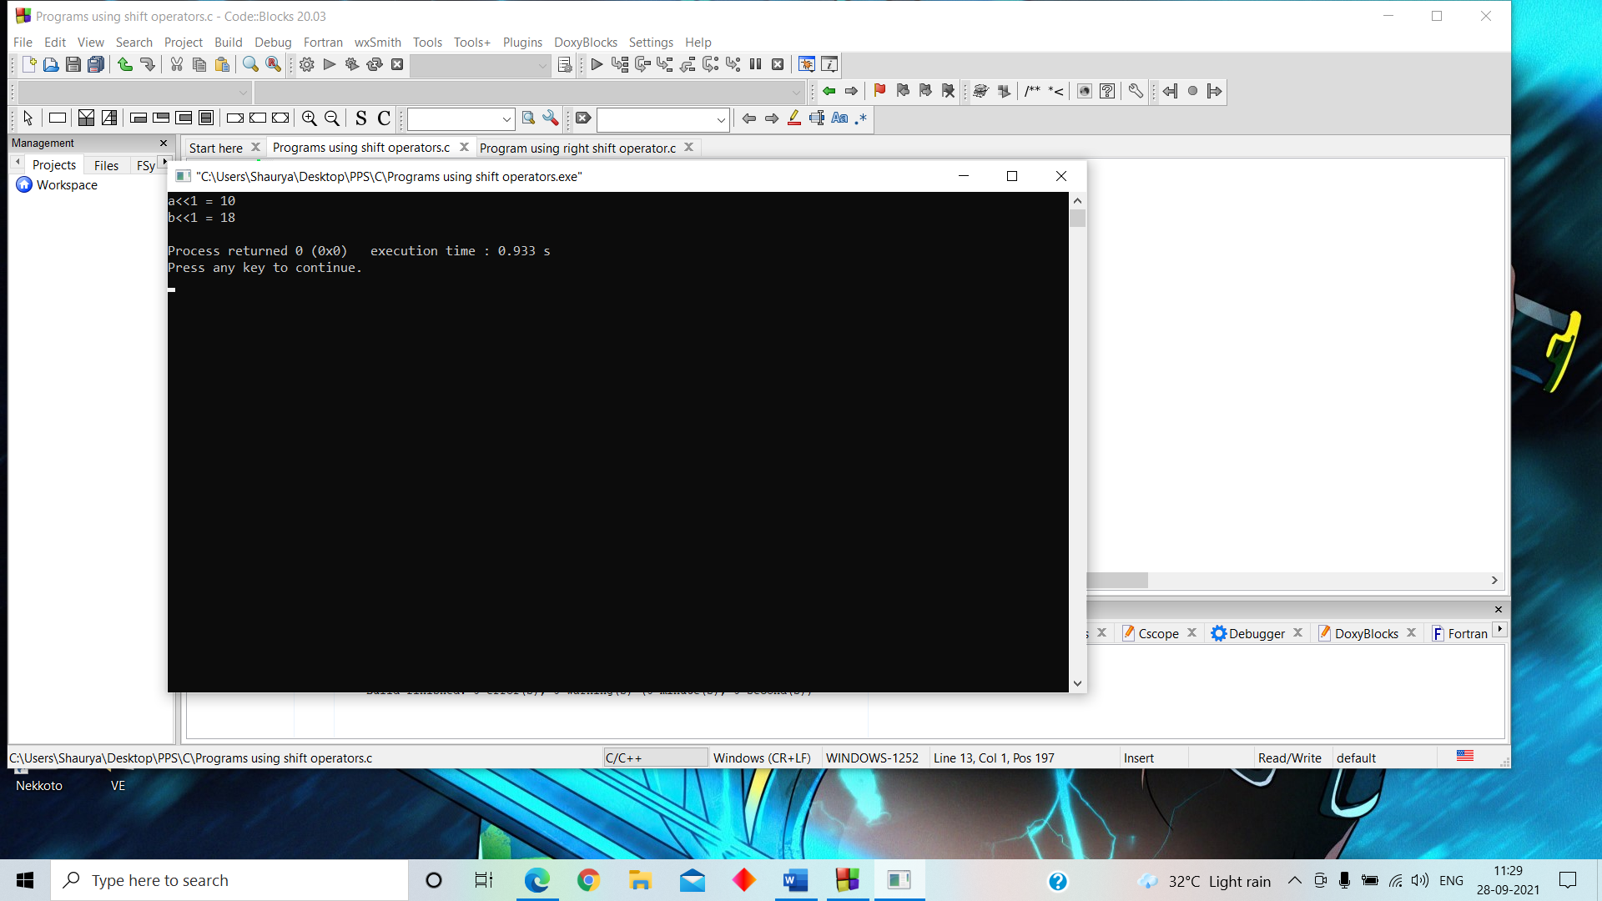OUTPUT-

**//Programs using right shift operator**

#include<stdio.h>

int main()

{

unsigned char a = 5, b = 9;

printf("a>>1 = %d\n", a >> 1);

printf("b>>1 = %d\n", b >> 1);

return 0;

}

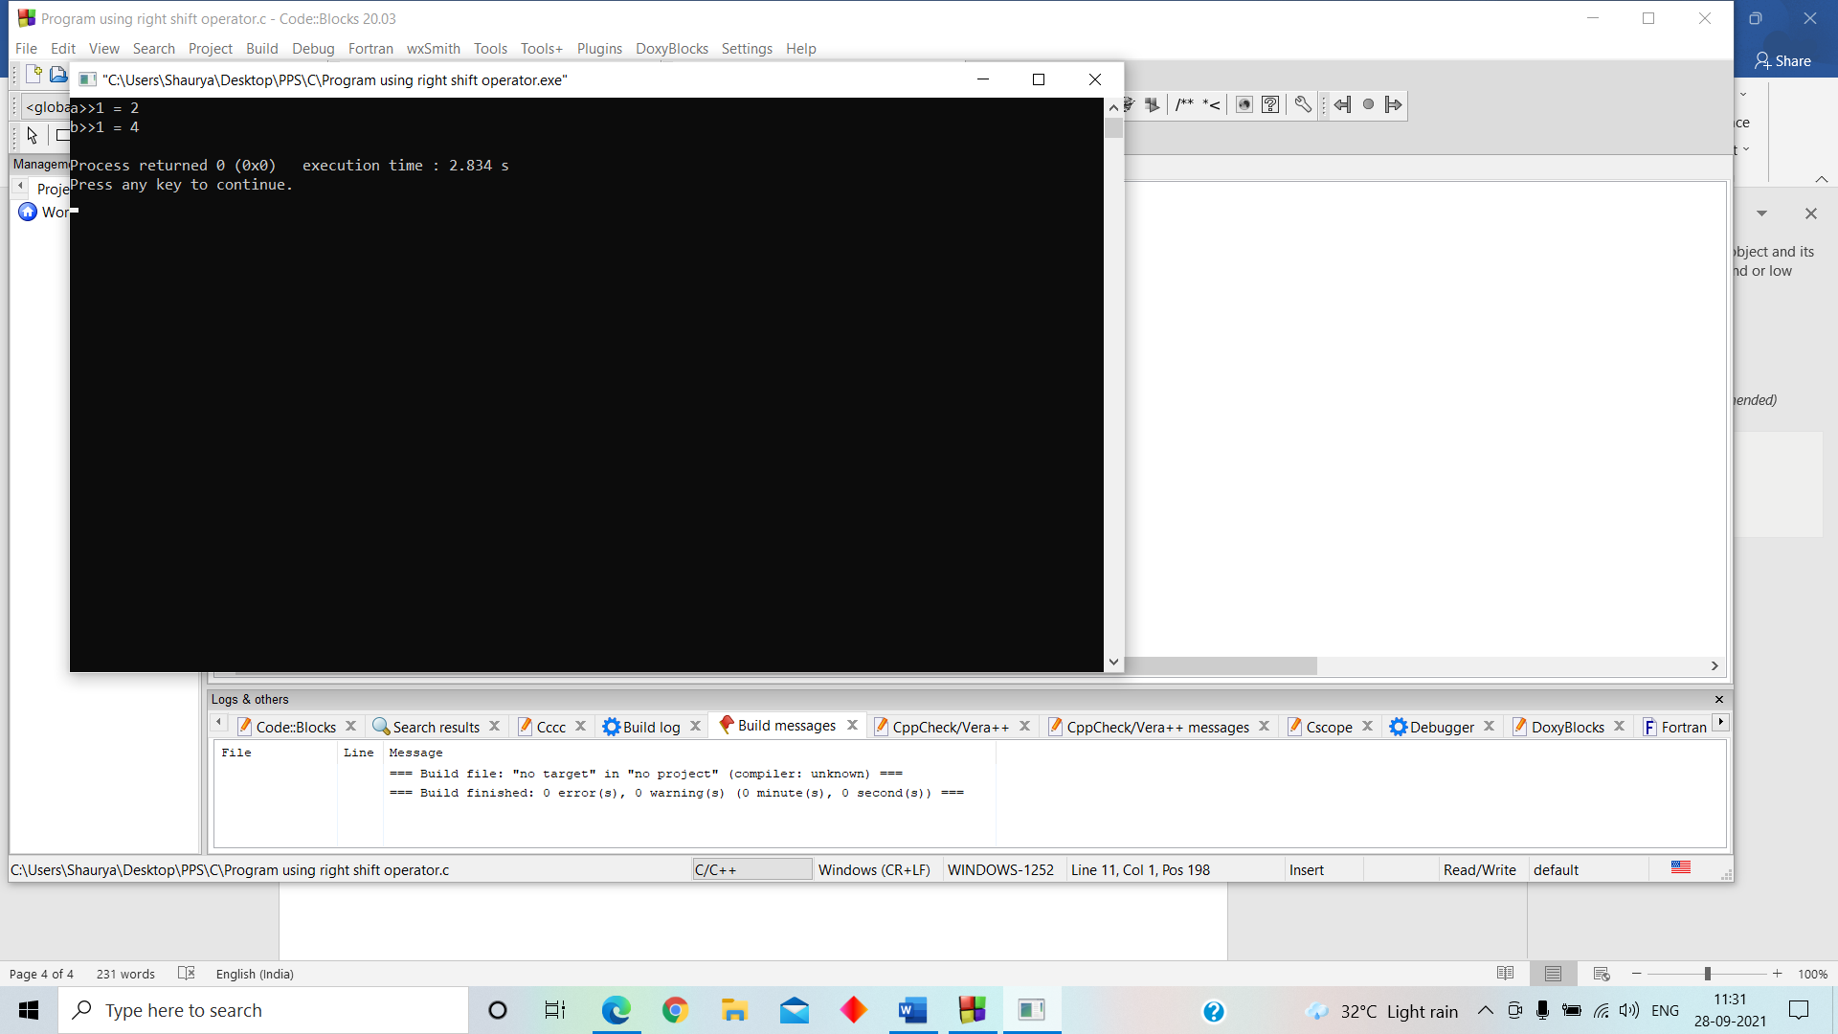OUTPUT-

**//Read a character from the user and display the ASCII value of the character.**

#include <stdio.h>

int main()

{

char c;

printf("Enter the character: ");

scanf("%c", &c);

printf("The character is %c\n", c);

printf("The ASCII value of the character is %d", c);

return 0;

}

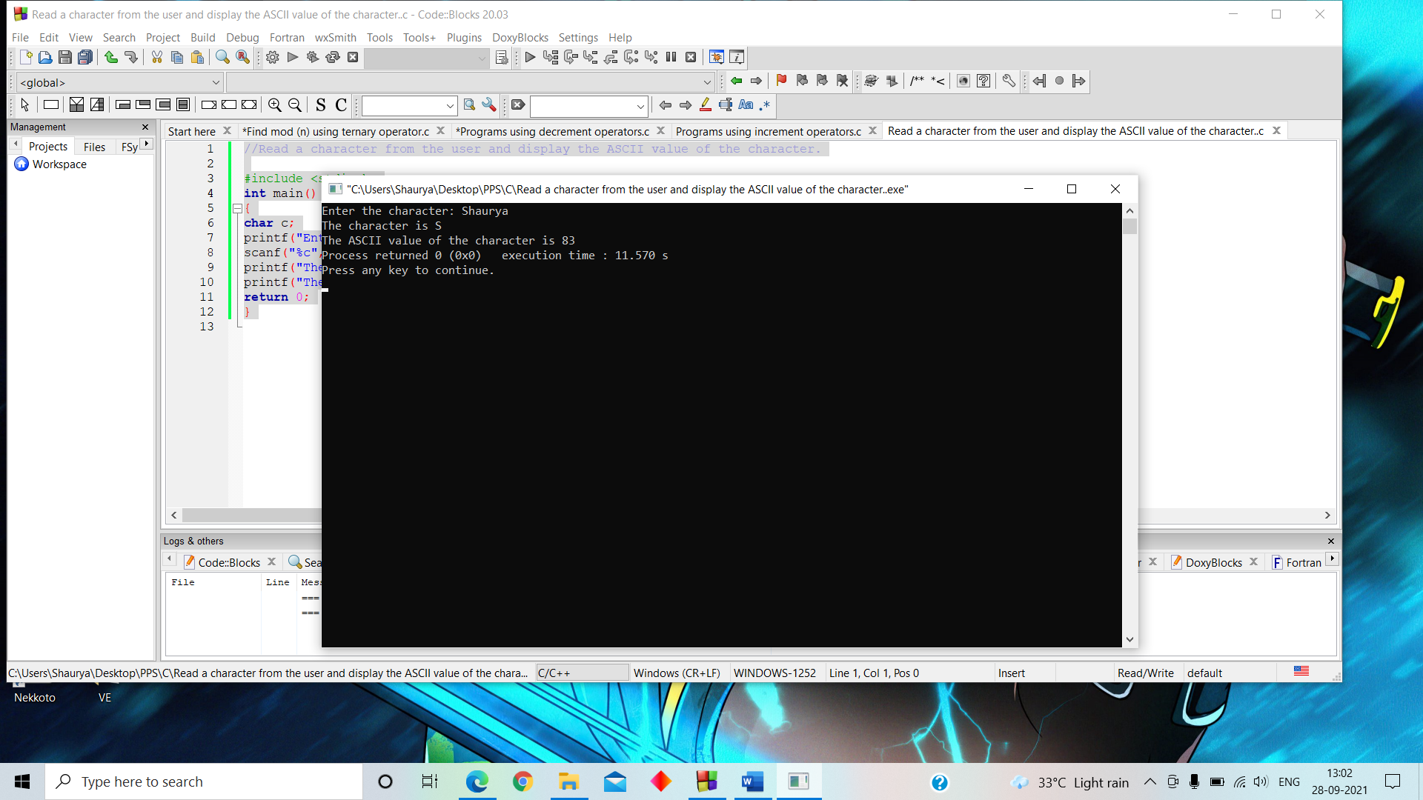OUTPUT-

**//Find |n| using ternary operator**

#include <stdio.h>

int main()

{

int n, abs;

printf("Enter a Number: ");

scanf("%d", &n);

abs = (n > 0) ? n : (-n);

printf("The absolute value of %d is %d", n, abs);

return 0;

}

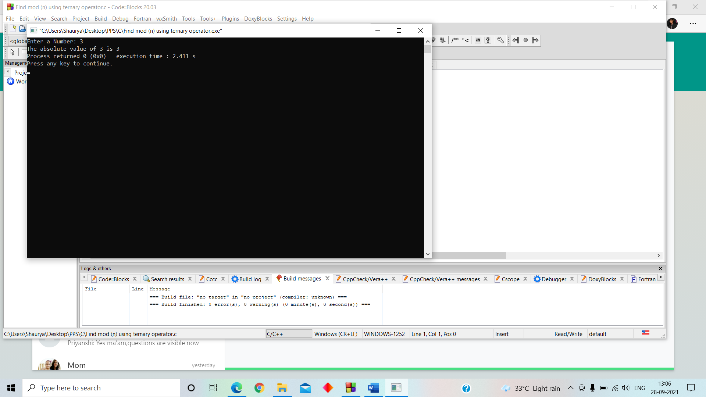OUTPUT-

**//Programs using increment operators**

#include <stdio.h>

int main()

{

int n;

printf("Enter a Number: ");

scanf("%d", &n);

printf("The number is %d", n);

printf("\nThe number after pre-increment is %d", ++n);

printf("\nThe number after 1st post-increment is %d", n++);

printf("\nThe number anfter 2nd post-increment is %d", n++);

return 0;

}

OUTPUT-

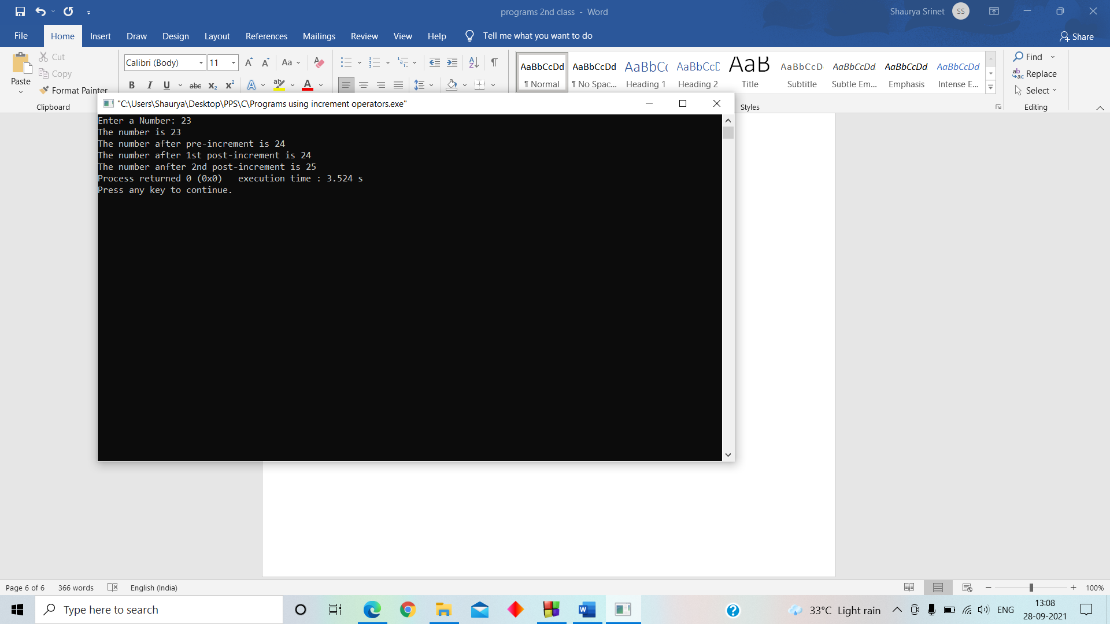

**//Programs using decrement operators**

#include <stdio.h>

int main()

{

int n;

printf("Enter a Number: ");

scanf("%d", &n);

printf("The number is %d", n);

printf("\nThe number after pre-decrement is %d", --n);

printf("\nThe number after 1st post-decrement is %d", n--);

printf("\nThe number anfter 2nd post-decrement is %d", n--);

return 0;

}

OUTPUT-

